EduGenie – Google Gemini Powered Learning Assessment
Project Design
1. Introduction
EduGenie is a Google Gemini powered learning and assessment system designed to support students with interactive learning content and AI-assisted assessments. The system combines a simple user interface, backend services, Gemini AI, and assessment functions to provide a structured digital learning experience.
2. Project Design
The project design defines the major modules and their interaction. The student uses the learning interface to select a topic and access assessment activities. The backend manages requests and connects the application with Gemini AI and the database. The assessment engine evaluates responses and presents results.
3. Architecture Diagram
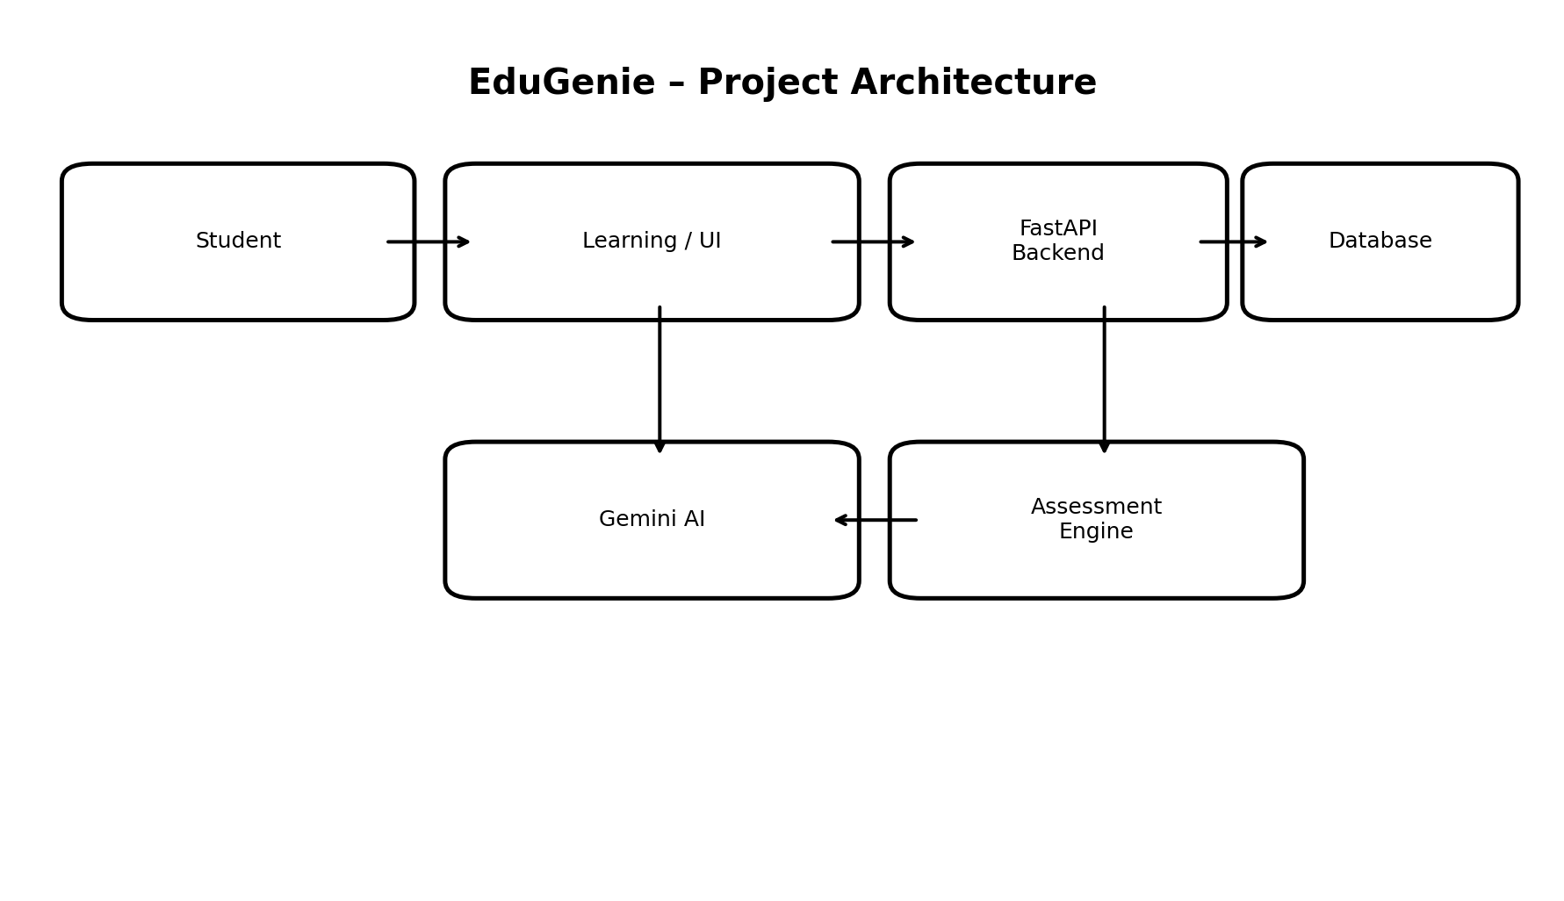
Figure 1: EduGenie project architecture.
4. UI Design
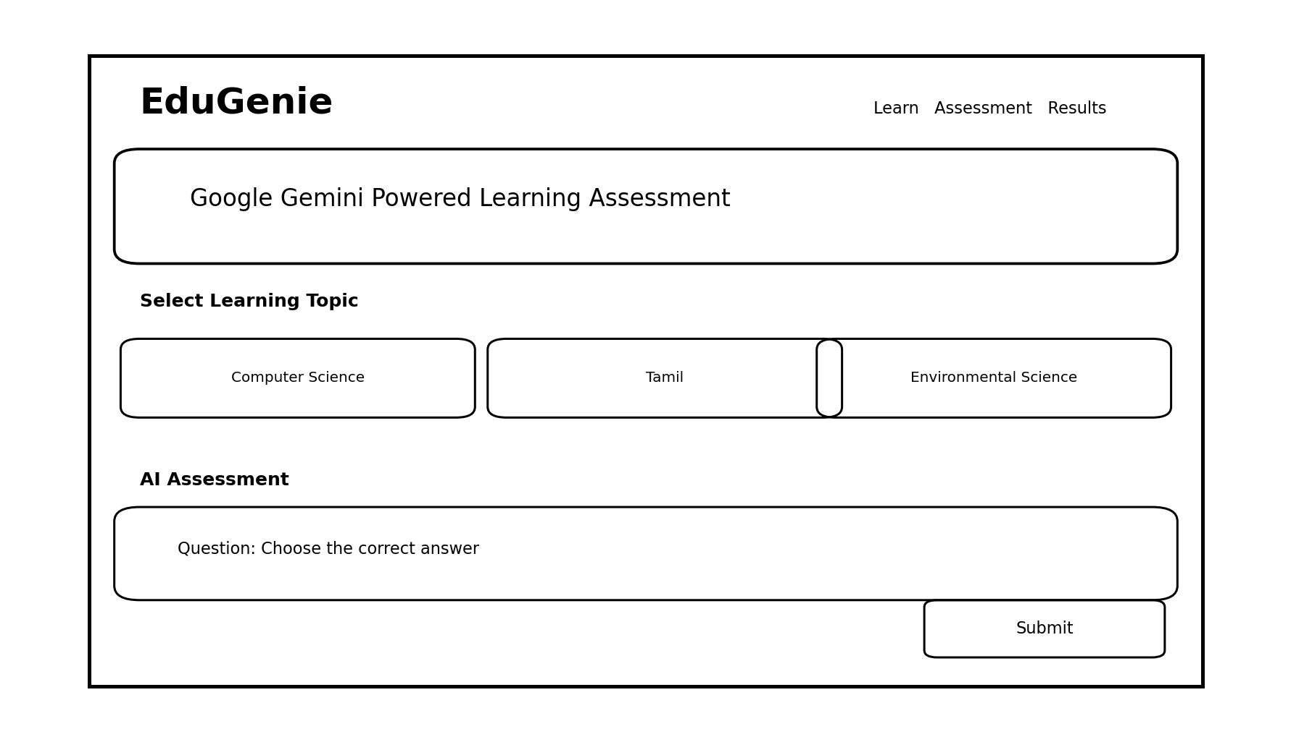
Figure 2: EduGenie learning and assessment UI mockup.
5. Main Components
- Student interface – provides learning, assessment, and result screens.
- Gemini AI – supports intelligent learning content and assessment generation.
- FastAPI backend – processes application requests and connects the main services.
- Assessment engine – manages questions, answers, scoring, and feedback.
- Database – stores required application and assessment information.
6. Design Objectives
- Provide a simple and student-friendly learning interface.
- Use Gemini AI to support personalized learning and assessment.
- Make assessment and feedback easy to understand.
- Maintain clear communication between the UI, backend, AI service, and database.
- Support an organized and scalable project structure.
7. Conclusion
The EduGenie project design provides a clear framework for a Google Gemini powered learning and assessment application. By connecting the user interface, backend, Gemini AI, assessment engine, and database, the system can deliver interactive learning and structured assessment. The proposed design also provides a strong foundation for future development and additional learning features.

